Communication preferences

Template

Step 1:

1. In the first column, from the list of behaviors below, please choose the top 7 that most resonate with you, by marking a tick ü next to it.
2. On the second column, from the 7 behaviors that you have ticked, now select your top 5 and rank them from most like you (1) to least like you (5).

|  |  |  |
| --- | --- | --- |
| Behavior | My top 7 **ü** | Rank your top 5  *(1 = most like you; 5 = least like you)* |
| Likes challenges | ü | 2 |
| Results focused |  |  |
| Competitive | ü | 3 |
| Determined |  |  |
| Assertive | ü | 4 |
| Decisive |  |  |
| Risk Taker | ü | 5 |
| Sensitive to others |  |  |
| Sociable |  |  |
| Emotional |  |  |
| Stimulating |  |  |
| Outgoing | ü |  |
| Optimistic | ü | 1 |
| Enthusiastic |  |  |
| Tactful |  |  |
| Calm |  |  |
| Patient |  |  |
| Dependable | ü |  |
| Supportive |  |  |
| Accommodating |  |  |
| Procedure orientated |  |  |
| Precise |  |  |
| Private |  |  |
| Systematic |  |  |
| Restrained |  |  |
| Likes numbers |  |  |
| Perfectionist |  |  |
| Critical of mistakes |  |  |

Step 2:

Now please complete your research. Here is a reminder of DiSC. The example behaviors are drawn from the previous table.

Introducing the DiSC model

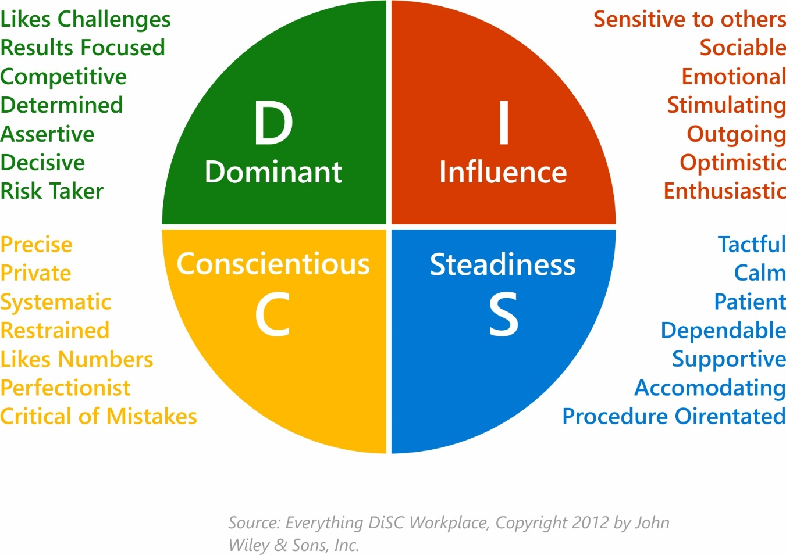

Step 3:

Following your research, answer the final 2 questions below.

1. What have you learned about yourself from the DiSC model?

I have two quality (D) and (I). From the research I feel this is a true reflection as I can identify with many of the behaviors and can see how this comes across when I communicate and how I prefer people communicate with me. I think I flex between D and I, depending on the situation. At work I’m more likely to communicate in more of a D approach, but at home I think I communicate using I more often.

1. What have you learned about DiSC and its value when communicating with others?

I now understand why I get frustrated when people communicate with me in a

‘Steadiness’ or ‘Conscientious’ style, as this is not my natural way of communicating.

It has allowed me to understand this more from their perspective and appreciate why

they communicate in this manner. I also now recognize why I need to adapt to their

style at times, as my style probably frustrates them.

I think DiSC will help me to become a better communicator.